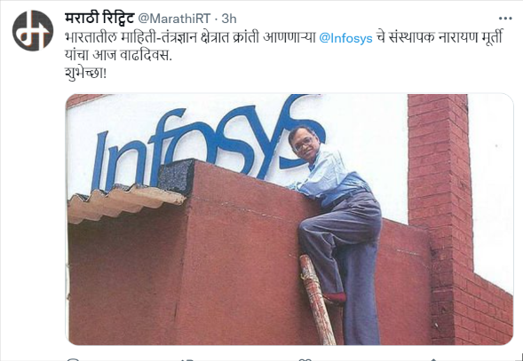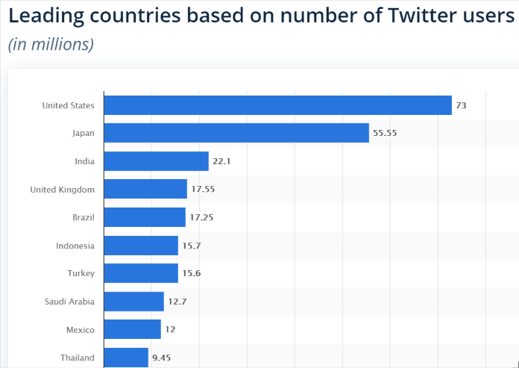

Twitter users in India are among the top three in the world but they are miniscule as compared to India’s population. Government reports suggest that there is going to be a surge in the no social media users in India in the next decade as schemes like National optical fibre network and others help internet spread in the remotest villages of India.9 out of 10 new social media users are going to be the ones who will be using these apps in Indian languages. Hence in anticipation of the tremendous data they are going to generate there is a need for opinion mining in Indian languages like Marathi which is third most spoken language in the country after Hindi and Bengali, we plan to develop an opinion mining dashboard where users can feed in individual tweets or texts or csv files and they can get the output feedback on a scale of 1 to 10, where 10 being the most positive while 1 being the most negative.

This platform will help companies to get feedback about their products mainly from rural Maharashtra and Goa where majority of the speakers speak the Marathi language, helping them assess their product and making required changes if required.

With the pandemic going on, governments can analyse the opinion of the citizens who are the heart of democracy and take their suggestions on lockdowns and other government measures helping government taking a more informed decision.

There have been instances in the developed countries like USA where influential figures like the president himself were accused of spreading riots, hence with increasing social media users in India too which must make sure that platforms like twitter are not used for spreading hate and anarchy.

Twitter or any other social media platform is a double edged sword if it be used to spread hate by one it can also be used to spread peace by thousand others and can help in spreading an act of kindness motivating others who will know that good acts will be rewarded.

Twitter has been used in an innovative way by students in uttarakhand who were protesting against no timely examination in their universities.Government officials at the echelon can get connected to the people at the ground using such platforms and make necessary course correction.

